CmpE 110 LAB3 Dr. Ahmet Bindal

Part 1: Inverter rise and fall propagation delays and times as a function of output load

Find an inverter from the LTSPICE digital circuit library, and connect the output of the CMOS inverter shown below to the inputs of multiple identical inverters, all in parallel. Here, you are creating fan-out for the inverter under test. Fan-out in digital circuitry is defined as the number of identical inverters, all connected in parallel to the OUT terminal of the single CMOS gate. Leave the outputs of the “fan-out” inverters floating. Add a pulse generator to the input that changes between 0 and 5V. Measure the rise and fall propagation delays, the rise and fall times as a function of fan-out. Increase the capacitance values from 0nF to 500nF in 50nF segments, i.e. 0, 50, 100, 150, 200…500nF.
Start your measurements by not connecting the output of the inverter to any load (capacitance = 0nF), and then increase by 50nF at a time. Plot rise and fall propagation delays, the rise and fall times as a function of fan-out

What are the values of effective NMOS resistance, R_{N}, and effective PMOS resistance, R_{P}?
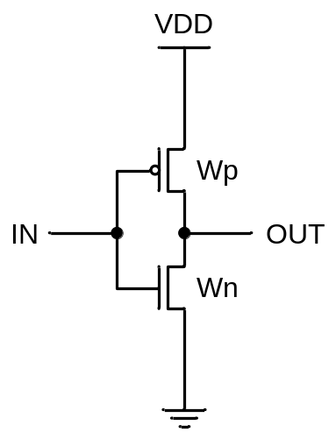

Part 2: Two-input NAND gate rise and fall delays and times as a function of output load

Connect the output of a single CMOS NAND-gate from the LTSPICE digital library to the inputs of multiple identical 2-input NAND gates. You are thereby creating fan-out for the 2-input NAND-gate under test. Make sure to connect the A and B-terminals of the 2-input NAND “fan-out” gates together to form a capacitive load. The outputs of the load gates must be left unconnected (floating). Measure the rise and fall propagation delays, the rise and fall times as a function of fan-out.

Use a pulse generator that changes between 0 and 5V. Start your measurements by not connecting the output of the 2-input NAND gate to any load (capacitance = 0nF). Increase the capacitance values from 0nF to 500nF in 50nF segments, i.e. 0, 50, 100, 150, 200…500nF.

Record the best and worst-case propagation rise and fall delays, rise and fall times in each case. Tabulate and plot your results as a function of fan-out. What are the values of effective NMOS resistance, R_{N}, and effective PMOS resistance, R_{P}?

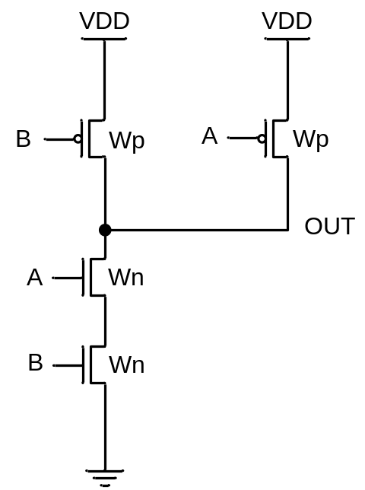

Part 3: 2-input NOR gate rise and fall delays and times as a function of output load

Connect the output of a single CMOS NOR-gate from the LTSPICE digital library to the inputs of multiple identical 2-input NOR-gates. You are again creating fan-out for the 2-input NOR-gate under test. Make sure to connect the A and B-terminals of the 2-input NOR “fan-out” gates together to form a capacitive load. The outputs of the load gates must be again left unconnected (floating). Measure the rise and fall propagation delays, the rise and fall times as a function of fan-out.

Use a pulse generator that changes between 0 and 5V. Start your measurements by not connecting the output of the 2-input NOR gate to any load (capacitance = 0nF). Increase the capacitance values from 0nF to 500nF in 50nF segments, i.e. 0, 50, 100, 150, 200…500nF.

Record the best and worst-case propagation rise and fall delays, rise and fall times in each case. Tabulate and plot your results as a function of fan-out. What are the values of effective NMOS resistance, R_{N}, and effective PMOS resistance, R_{P}?

